4. To build an Artificial Neural Network using the Backpropagation algorithm and classify a new sample.
Procedure
- Import the MLPClassifier.
- Create the training dataset and target values.
- Create the ANN model.
- Train the model using Backpropagation.
- Test the model using a new sample.
- Display the predicted result.

Dataset 1: Student Placement Prediction
CGPA | Communication | Internship | Programming | Placement
9 | Excellent | Yes | Excellent | Placed
8 | Good | Yes | Good | Placed
7 | Good | Yes | Average | Placed
6 | Average | No | Average | Not Placed
5 | Poor | No | Poor | Not Placed
9 | Excellent | Yes | Good | Placed
8 | Good | No | Good | Placed
6 | Average | Yes | Average | Not Placed
7 | Excellent | Yes | Good | Placed
5 | Poor | No | Average | Not Placed
Target Variable
Placement (Placed / Not Placed)
New Sample
CGPA | Communication | Internship | Programming
8 | Excellent | Yes | Good
Code and Output:

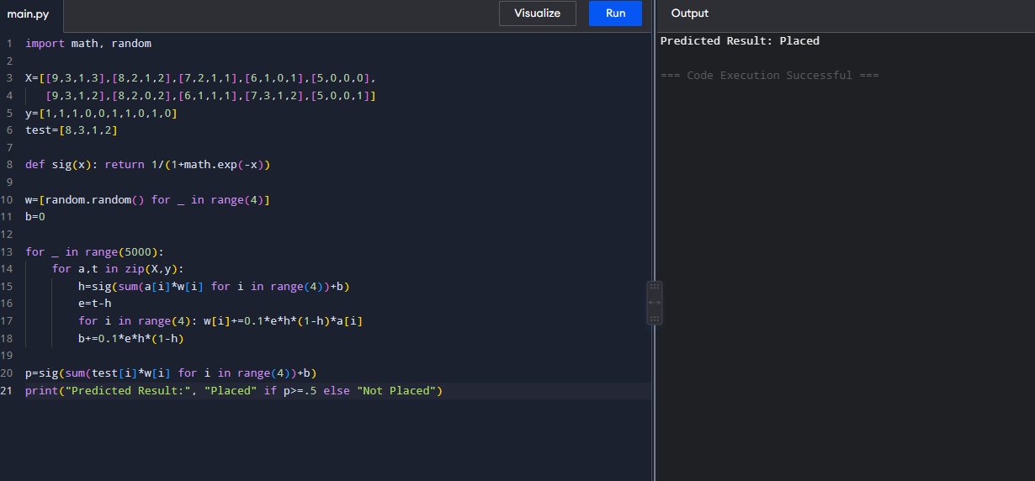

Dataset 2: Loan Approval Prediction

Income | Credit Score | Employment | Property | Loan Approved
High | Good | Permanent | Yes | Yes
High | Good | Permanent | No | Yes
Medium | Good | Permanent | Yes | Yes
Medium | Average | Permanent | No | Yes
Low | Poor | Temporary | No | No
Low | Average | Temporary | Yes | No
High | Average | Permanent | Yes | Yes
Medium | Good | Temporary | No | No
High | Good | Permanent | Yes | Yes
Low | Poor | Temporary | Yes | No
Target Variable
Loan Approved (Yes / No)
New Sample

Code & Output:

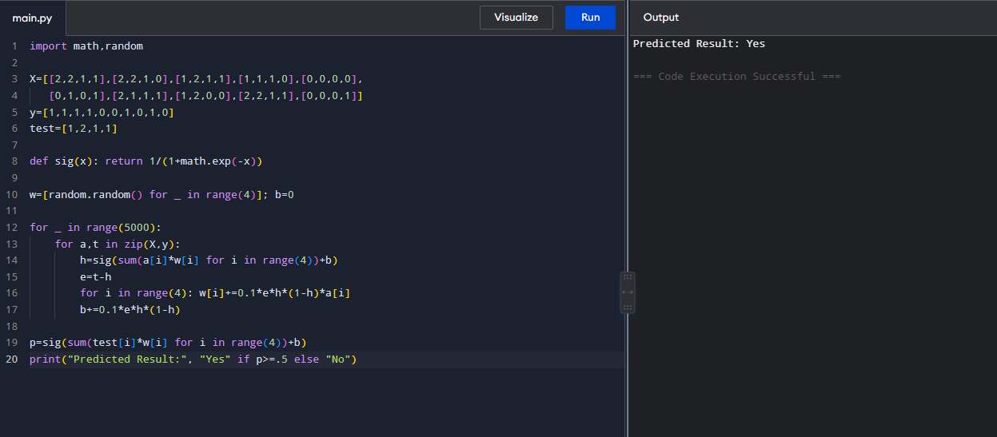

Dataset 3: Disease Diagnosis

Fever | Cough | Headache | Body Pain | Fatigue | Disease
Yes | Yes | Yes | Yes | Yes | Positive
Yes | Yes | No | Yes | Yes | Positive
No | Yes | Yes | No | No | Negative
Yes | No | Yes | Yes | Yes | Positive
No | No | No | No | No | Negative
Yes | Yes | Yes | No | Yes | Positive
No | Yes | No | Yes | No | Negative
Yes | No | No | Yes | Yes | Positive
Yes | Yes | Yes | Yes | Yes | Positive
No | No | Yes | No | No | Negative
Target Variable
Disease (Positive / Negative)

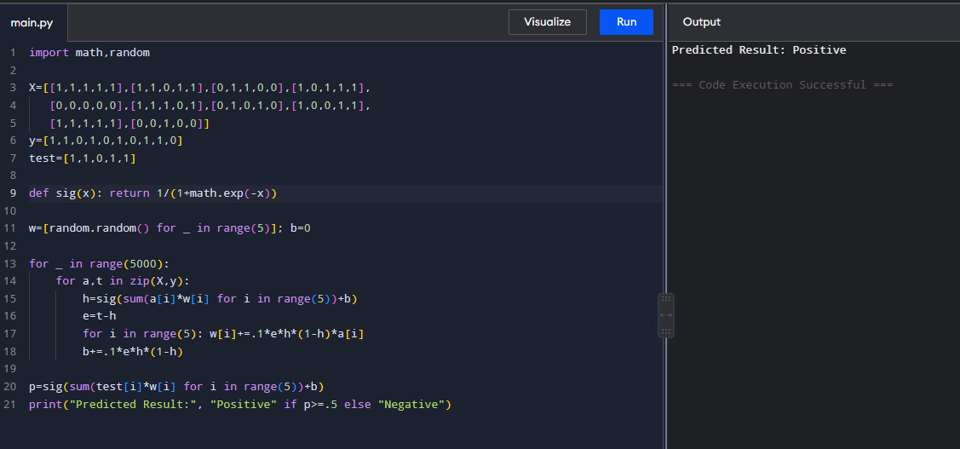

Dataset 4: Employee Promotion Prediction

Experience | Performance | Leadership | Training | Promotion
High | Excellent | Yes | Yes | Promoted
High | Good | Yes | Yes | Promoted
Medium | Good | Yes | Yes | Promoted
Medium | Average | No | Yes | Not Promoted
Low | Poor | No | No | Not Promoted
High | Excellent | Yes | No | Promoted
Medium | Good | No | Yes | Promoted
Low | Average | No | No | Not Promoted
High | Good | Yes | Yes | Promoted
Low | Poor | No | Yes | Not Promoted
Target Variable
Promotion (Promoted / Not Promoted)

Code & Output:

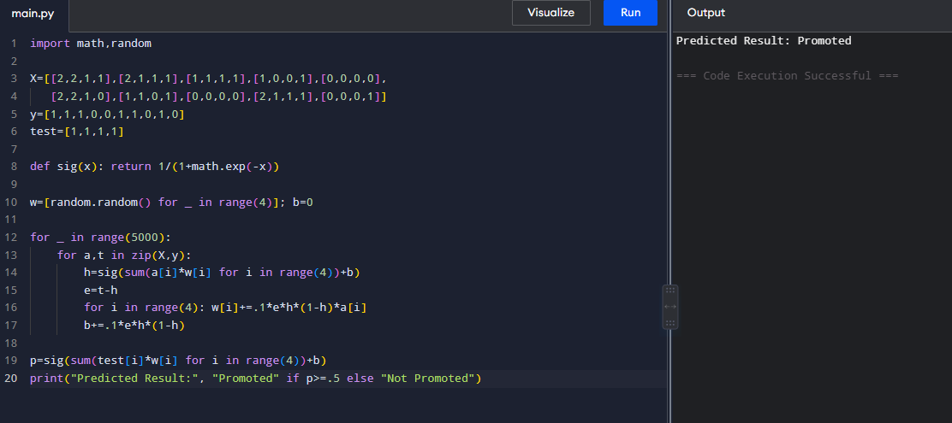

Dataset 5: Email Spam Detection

Contains Link | Offer Words | Unknown Sender | Attachment | Many Recipients | Spam
Yes | Yes | Yes | No | Yes | Spam
Yes | Yes | Yes | Yes | Yes | Spam
No | No | No | No | No | Not Spam
Yes | No | Yes | No | Yes | Spam
No | Yes | No | Yes | No | Not Spam
Yes | Yes | Yes | No | No | Spam
Yes | No | Yes | Yes | Yes | Spam
No | No | Yes | No | No | Not Spam
Yes | Yes | No | No | Yes | Spam
No | No | No | Yes | No | Not Spam
Target Variable
Spam (Spam / Not Spam)

Code and Output:

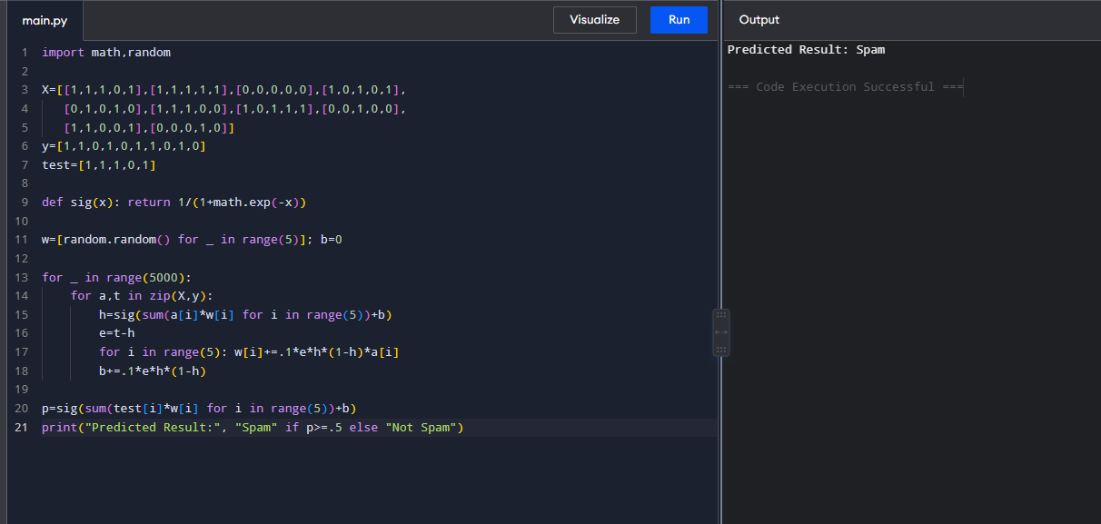

Result:
ANN Model Trained Successfully
New Sample Tested Successfully
Predicted Result: Placed

